RELEASE FABRIC | PEELPLY A 100 PS

DESCRIPTION

A100PS is a porous nylon release fabric

Heat set and scoured - can be used directly against laminates or bond lines.

Identical to release fabric A100 apart from the addition of a red tracer yarn spaced every 30mm along the warp direction of the fabric for ease of identification on the cured laminate. This is particularly useful when working with very large moldings which are typically found in the marine industry where secondary bonding could be compromised should any release fabric be inadvertently left behind on the laminate.

APPLICATION

Will release from most commercial resin systems.

Note: A100PS is not recommended for use with phenolic resins or prepregs or used at temperatures higher than 180°C. If this temperature is exceeded, it is suggested that our coated nylon release fabrics A8888 or B4444, or porous PTFE release fabric FF/03/PM be used.

PHYSICAL PROPERTIES

Maximum Cure Temperature 180°C
Fabric Thickness (nominal) 0.145mm
Fabric Weight (nominal) 80 g/m²
Color Natural (white) with red tracer yarn

AVAILABILITY & PACKAGING

Roll sizes 100m x 1.52m wide
Slit widths available

STORAGE & HANDLING
No special storage conditions required.
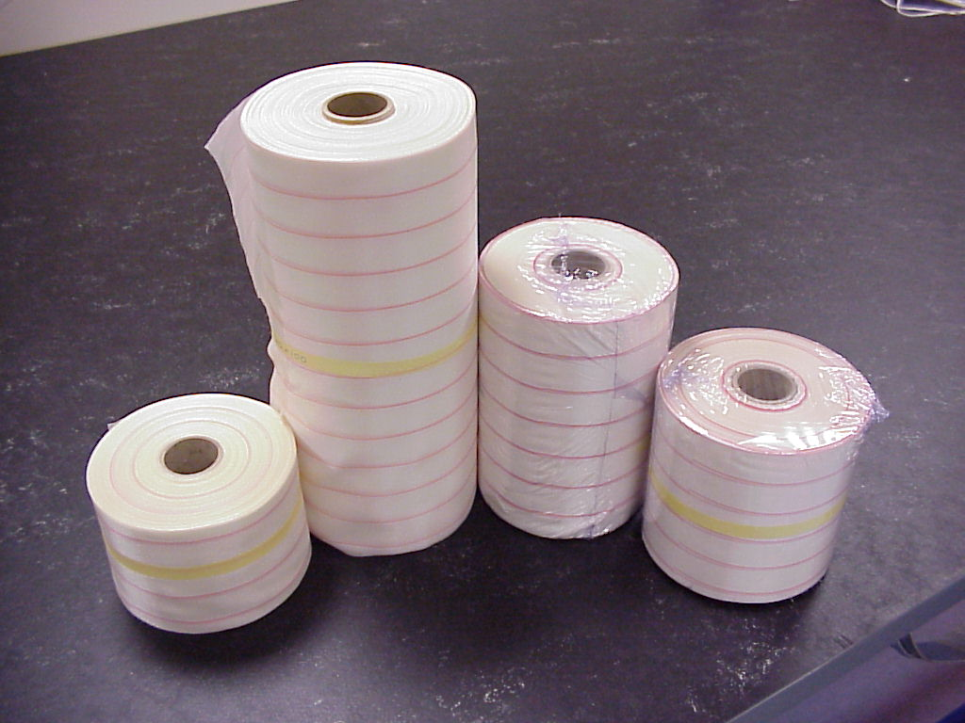

ISSUE DATE OCTOBER 2000


P.O.Box 93 Tel. +358 9 681 081
FIN 00211 Fax. +358 9 692 4174
HELSINKI

